1. A [**Boolean data type**](https://en.wikipedia.org/wiki/Boolean_data_type) is a data type with only two possible values: [**true**](https://en.wikipedia.org/wiki/Truth)or[**false**](https://en.wikipedia.org/wiki/False_(logic))**.**

Example:

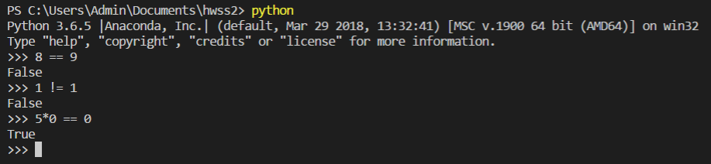

1. - **Nested conditions** comprise condition statements contained within the definition of other condition statements. **Nested conditions** work as follows:

* You can group multiple condition statements. Conditions consisting of multiple statements are connected using the logical “**AND**” and “**OR**” operators.
* You can also nest statements, so that one statement is contained within the definition of another statement.

- In a nested if construct, you can have an **if...elif...else** construct inside another **if...elif...else** construct.

Example:

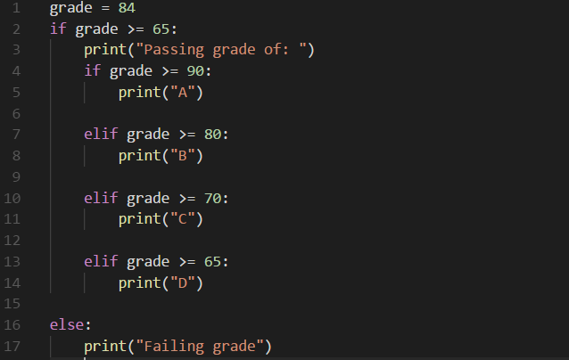

1. - A flowchart is a formalized graphic representation of a logic sequence, work or manufacturing process, organization chart, or similar formalized structure.

* Draw **flowchart** for the following code:

Handsome

Even more handsome

OTHER

Web browser open(“<https://www.youtube.com/watch?v=04854XqcfCY>”)

MINH DUC

ANH QUAN

What’s your name??